APPENDIX A: Suggested Planning Schedule
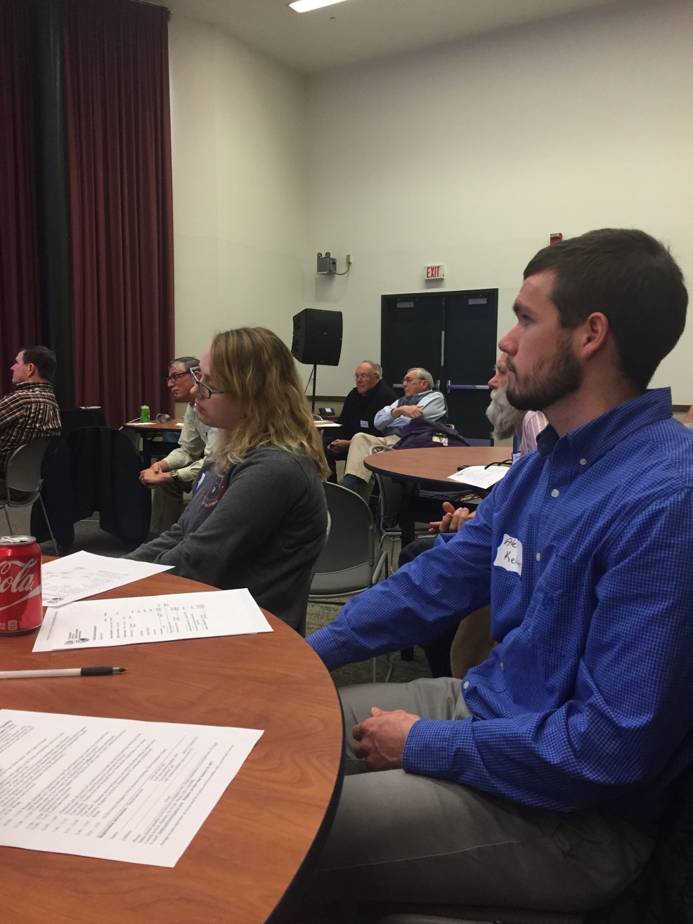

APPENDIX B: Example Agendas

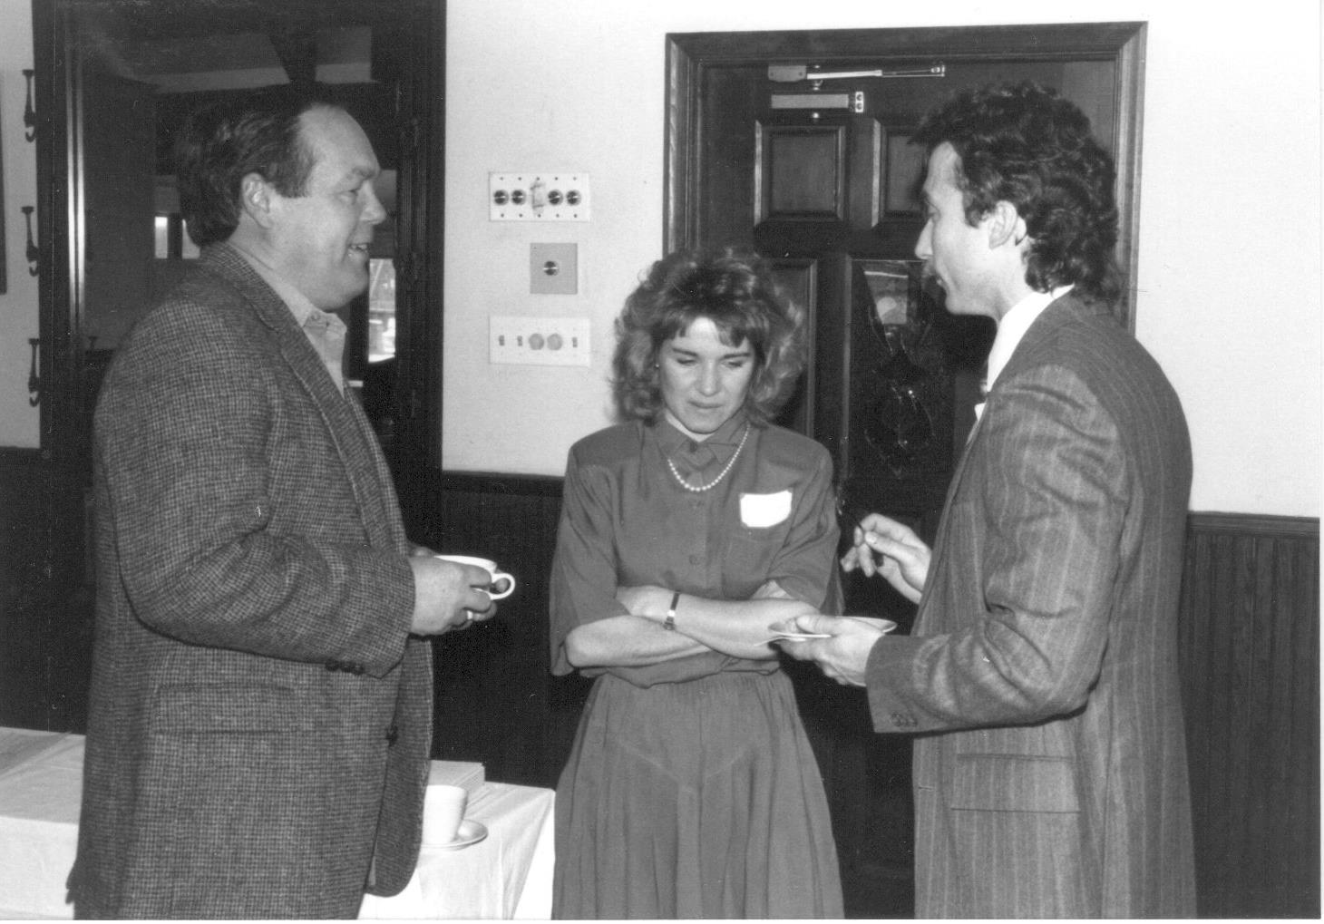
APPENDIX C: Example Budgets

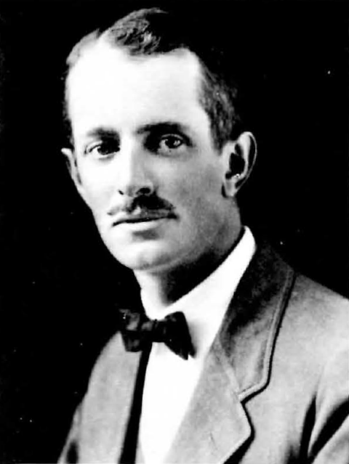
Appendix D: Reginald D. Forbes Art Contest

Reginald D. Forbes (c.1927)

