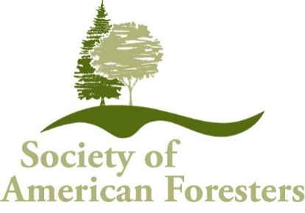
Request for Proposals
Allegheny Society of American Foresters Education Endowment Fund

The Allegheny Society of American Foresters Education Endowment Fund (known as “The Fund”) was established in 1984 and amended in 2003 to provide grants for the support of educational programs within the Allegheny Society region. Income from The Fund can be designated for educational projects but the principle value of the endowment must be maintained so the amount available for grants will vary each year.

Funding Criteria:
- Grant proposals can be submitted by a subdivision of Allegheny SAF (Chapter, Division, etc) for developing, promoting, or carrying out education programs for forestry professionals and the public.
- Highest priority will be given to requests that provide the greatest benefit to the Allegheny SAF.
- Grants can be used to subsidize the cost of programs. The grant would need to reduce costs so that the program would be economically feasible for the greater number of participants.
- Grants for the training of individual Allegheny SAF members will have low priority for funding. The exception to this would be if the training of the individual was encompassed into the plan of a larger education program which included the dissemination of information obtained in the training to a larger audience within Allegheny SAF.

Application Procedure:
Requests for funding cannot exceed $2500 and can be submitted for consideration two times per year:
- December 15 – notification of award by January 30 of the next year
- June 15 – notification of award by July 31.

If no funding is available for a specific submission date, the submitters of proposals will be contacted and encouraged to reapply for the next submission date. For funded projects, the funds will be provided shortly after notification with $250 withheld upon receipt of the final project report.

The request should provide the following information:
- Objective of the program
- Complete program plan for the proposed activity which can not exceed one year
- Plan for evaluating impact
- Outcome measures, impact metrics, and/or deliverables.
- Proposed budget including all estimated expenditures and all proposed sources of income

A follow-up report is required within 60-days after the end of the project and will include:
- A two-page impact report with program objectives, description, and impacts, along with photographs or other related materials.

Proposals are to be submitted by email to the Allegheny SAF Education Committee:
- Committee members: Susan Lacy, Jonathan Kays, Steve Resh, Cecile Stelter, Steve Goodman.
- Submission contact info: Susan Lacy, Allegheny SAF, Endowment Fund Grant Program. Email: ansaf@comcast.net

