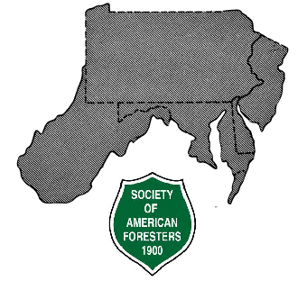

GUIDELINES FOR HOSTING SEMIANNUAL PROGRAMS
of the
Allegheny Society of American Foresters
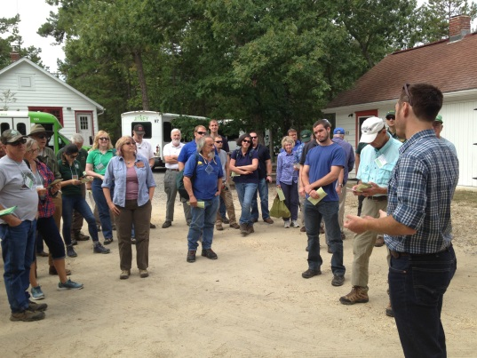

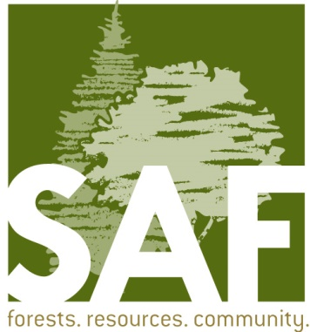

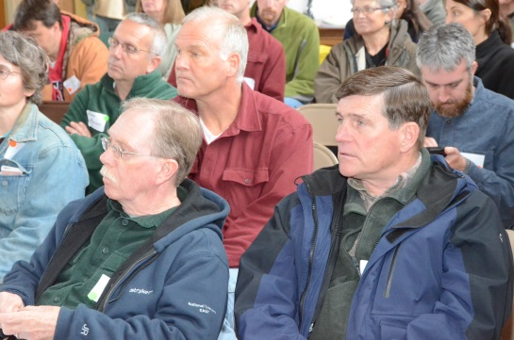

Last Revised: April 6, 2017

Table of Contents
In a Nutshell………………………………………………………………... 1

Introduction to Allegheny SAF Programs…………………………………. 2

Organization by the Host Chapter/Division……………………………….. 4

Elements of a Successful Program…………………………………………. 6

Finance and Budgeting…………………………………………………...... 13

Continuing Forestry Education credits (CFE’s) and everything else…….... 16

SAF Mission
The mission of the Society of American Foresters is to advance sustainable management of forest resources through science, education, and technology; to enhance the competency of its members; to establish professional excellence; and to use our knowledge, skills, and conservation ethic to ensure the continued health, integrity, and use of forests to benefit society in perpetuity.

Acknowledgements
This guide provides information for host chapters to use when planning a winter conference or summer training for the Allegheny Society of American Foresters (ANSAF). The information has been compiled using similar documents developed by other state and multi-state societies and an ANSAF document updated in 1983, and last revised in 2010. Photos included herein are courtesy of Charles Newlon and Steve Kallesser, excepting the NJ Division ANSAF archives for the photo at Appendix C, and the USDA Forest Service for the photo at Appendix D.

The Allegheny Society of American Foresters is deeply indebted to former program committee chair Ned Karger for his 10-year effort in that role, including his work on the 2010 revision to this document.

About the program committee
Additional information, including digital copies of budget spreadsheets can be found at: www.alleghenysaf.org/docs Does any part of this document need updating or editing? The ANSAF program committee chair’s contact information can be found in the most recent edition of The Allegheny News.

The ANSAF program committee is a standing committee, whose responsibilities according to the by-laws (last revised 2009) are to schedule and coordinate the Allegheny Society semiannual meetings in conjunction with the host chapter/division and any additional meetings as may be deemed desirable by the Executive Committee. The committee is composed of a chair (appointed by the ANSAF Chair), and the designees for all host chapters/divisions who have committed to host an ANSAF program during the next 24 months.

The schedule is set up to rotate program host responsibilities between the New Jersey Division, Maryland/Delaware Division, West Virginia Division, and the seven Pennsylvania chapters. It also attempts to rotate hosting between summer and winter programs. Any chapter/division may volunteer to host more often or to co-host with another chapter/division. This schedule should be kept 2 to 4 years ahead to allow ample planning time and to permit divisions and chapters to volunteer to host more frequently if they so desire.

The program chair also monitors the progress of the local host planning committee, and offers guidance to the local leaders. The program chair also facilitates any needed communication to the ANSAF Chair, in the event of any needed action on the part of ANSAF.

