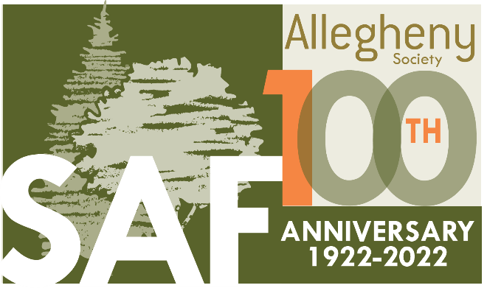

“Young Forests and Young Professionals”

2022 Allegheny SAF Winter Training
February 16-18, 2022; Gemmell Center, Clarion University, Clarion PA

Please plan to join us “in person” for the 2022 Allegheny SAF Winter Training Conference to celebrate the 100th anniversary of Allegheny SAF. The training will be held February 16-18, 2022, at the Gemmell Center on the campus of Clarion University in Clarion, Pennsylvania.

The meeting theme is “Growing Young Forests and Young Professionals” which will focus on the ecological and habitat importance of early succession forests, and on the critical importance of recruiting and developing dynamic and skilled practitioners and leaders in the forestry profession and SAF.

Conference Facility:
All of our conference activities will be held on campus at Clarion University in the Gemmell Student Center, 1048 Payne Street, Clarion PA 16214. Parking will be available by permit (which will be distributed with your meeting registration) in Lots Number 14 and 16, located adjoining the Gemmell Center. We will abide by COVID-19 guidelines and requirements established by Clarion University. At present, all persons, whether vaccinated or unvaccinated, are required to wear masks indoors in all campus facilities.

Lodging and Room Reservations:
No lodging is available at the conference location at Clarion University. Numerous hotels are available at Exit 62 (Clarion, Route 68) off I-80.
Blocks of rooms have been arranged at:
Clarion Hampton Inn, (814) 226-4444, 10 rooms, SAF group rate $109.00
Clarion Holiday Inn Express, (814) 223-4010, 20 rooms, SAF group rate $89.00
Clarion Microtel, (814) 227-2223, 20 rooms, SAF group rate $70.00
Booking must be made at least two weeks prior to the event.
Additional hotels are available at Exit 62, including: Motel 6, (814) 226-8682; Quality Inn (814) 226-5230; Ramada Inn (814) 324-9044.

Registration:
Please complete the registration form, and return with payment (payable to Plateau Chapter SAF) to: Howard Wurzbacher, Plateau Chapter SAF
17374 N. Main St. Extension
Titusville, PA 16354

Online Payment/Registration is available through Eventbrite.com:
https://www.eventbrite.com/e/2022-allegheny-saf-winter-training-tickets-228964838997

Continuing Education Credits:
While continuing to improve your knowledge and skills as a professional, the conference will offer opportunity to earn continuing education credits. The final agenda will be submitted for review. SAF CFE, ISA, and SFI credits will be assigned as approved.

Reginald D. Forbes Art Show and Contest:
Since 1974, the art show and competition has been a regular part of the Allegheny SAF Winter Training Conference with the objective of fostering and displaying the artistic talents of foresters and their family members. All those interested are invited to submit entries. A display area for viewing artwork will be available in the Gemmell Center. There are three categories for entries: photography, flat art, and 3-D artwork. Awards will be determined by votes from the attendees.

Silent Auction:
We ask everyone who can to consider donating an item or items for the silent auction. A display area for items will be designated in the Gemmell Center. Proceeds from the Silent Auction will be donated to the Kurt Gottschalk Science Fund.

Sponsors/Exhibitors:
As a sponsor or exhibitor, you will be a key contributor to the success of our Winter Training Conference, providing added value and interest to the program. Please contact Travis Cunningham, telephone: (814) 706-7474, e-mail: tcunningham@foreconinc.com for information about Sponsorship or Exhibitor opportunities.

Student Sponsorships:
We have made an effort to encourage student attendance by minimizing costs for students; please consider the “Sponsor a Student” line item on the registration form.

Wednesday, February 16:
The Allegheny SAF Executive Committee meeting will be held in Room 246 of the Gemmell Center from 3:00 to 6:00 PM. The Icebreaker Social will be held in the Gemmell Center from 6:00 PM to 9:00 PM.

Two optional field tours will be available on Wednesday, February 16 from 1:00 to 4:00 PM. Participants will be expected to provide their own transportation (carpooling will be encouraged), and will be directed to the tour locations. One will be a visit to the Clarion Boards LLC medium density fiberboard facility in Shippenville, PA, operated by Kronospan LLC. The second will be a visit to Cook Forest State Park in Cooksburg, PA, featuring a hike through the old-growth forest cathedral (dress appropriately). There is no cost for these field tours, however pre-registration is required.
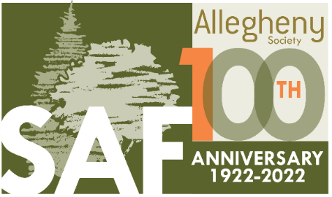

REGISTRATION FORM
Allegheny Society of American Foresters – Winter 2022 Training Conference
February 16-18, 2022 – Gemmell Center, Clarion University, Clarion PA

Meeting registration is due by: February 1, 2022. A late fee of $25.00 will be assessed for registrations postmarked after February 1, 2022. No registrations will be accepted after February 9, 2022.
Meeting Registration includes: all breaks, Thursday lunch, Friday Chairman’s Breakfast, and permit parking at Clarion University. Pre-registration is required for the Thursday Awards Banquet, at a cost of $25.00 per person.

Name: _____________________________________________________________

Address: ___________________________________________________________

Organization: _______________________________________________________

Telephone: ______________________ E-mail: ____________________________

SAF Member #___ @ $ 125.00 __________

Non-SAF Member #___ @ $ 150.00 __________

Student #___ @ $ 50.00 __________

Sponsor a Student ($25.00 / $50.00 / other) __________

Awards Banquet #___ @ $ 25.00 __________

Late Fee (for registrations postmarked after 2/1/22) $ 25.00 __________

Total Enclosed (checks payable to “Plateau Chapter SAF”) __________

Wednesday Field Tours: No. of people attending - Cook Forest __________
Clarion Board __________

Mail registration to: SAF Plateau Chapter, Howard Wurzbacher, 17374 N. Main St. Extension, Titusville, PA 16354. Questions? Please contact Howard Wurzbacher (814) 589-7538.

Online Registration and payment:
https://www.eventbrite.com/e/2022-allegheny-saf-winter-training-tickets-228964838997

